The Village Hall, Littlemore
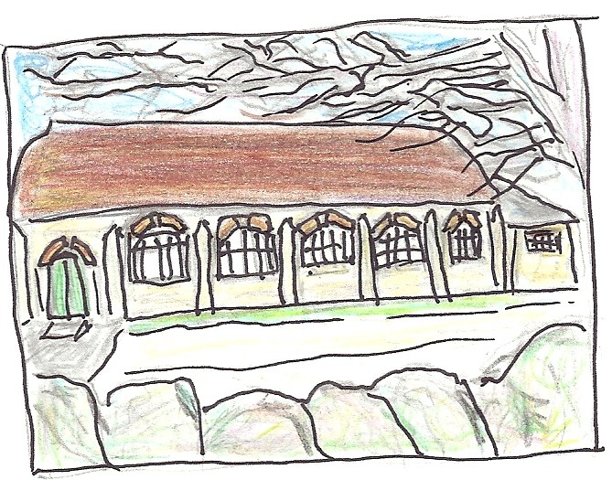

Facilities

The Hall
Littlemore Village Hall dates from the beginning of the twentieth century. It is built in a traditional Edwardian style, with walls of local stone and a tiled roof. Inside, red curtains and pictures on the wall give the hall a warm and friendly atmosphere.

The main hall measures 23' x 60'6" (7m x 18.5m)
It has an open stage at one end, with steps leading up to it. The wooden floor makes it very suitable for dancing.

Arranged in lecture style, it can seat 100 people.
Seated at tables, 70 people is the maximum.

Car park
There is parking space for approximately 10 cars in the hall car park. Overflow parking is available near by.

Access
The hall is easily accessible for wheelchair users. It has disabled toilet facilities.

Furniture
The hall is provided with:

- 13 large folding tables (2'3"x 6'/ 70 x 180cm)
- 3 small folding tables (2'3"x 4'/ 70 x 120cm)
- 4 small stacking tables (2'x 2'/ 60 x 60cm)
- 26 stacking banqueting chairs
- 50 upholstered folding chairs
- 15 chairs with arms
- 10 wooden Windsor chairs
- 4 low tables and 10 chairs suitable for young children

Kitchen Facilities
The kitchen opens off the hall. It provides basic facilities for preparing drinks and serving food. It is not equipped for full-scale catering and food preparation. Facilities include:

- 2 electric kettles
- domestic style electric cooker, with four rings,
grill and oven
- 2 refrigerators
- dishwasher
- microwave oven
- basic crockery and cutlery
- glass tumblers (but not wine glasses)
- plastic beakers and jugs

Sharp kitchen knives are not provided.

Equipment
A flip chart and a screen can be provided on request.

Games
A table tennis table, net and bats are available on request.
A pool table is also available, together with balls and cues, but must be booked in advance.

Music
Use of the piano can be arranged on request.

Garden
In the summer months, and in dry weather, users of the hall also have access to the rear garden. This features a large grassy area, and a patio with picnic table and garden chairs.

Further information
More information is available on our website,
at

This includes a calendar section showing availability.

Bookings
To make a booking, please use email if possible:
littlemorevillagehall@gmail.com

Alternatively, phone: 07467 127009

The Village Hall, Littlemore is a Charitable Incorporated Organisation, registered charity 1168882.
Address: Railway Lane, Littlemore, Oxford OX4 4PY

Updated 14.4.2020

