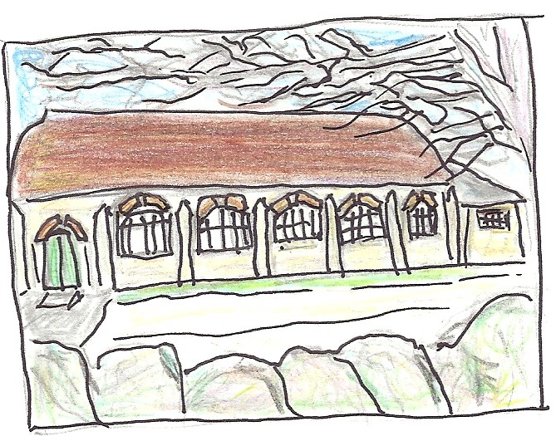
The Village Hall,
Littlemore

Registered Charity 1168882

Hire agreement: single use of the hall

1. Use.
The hall may only be used for the purpose and at the times on the booking form.
The hire charge covers use of the hall and the kitchen. They garden may also be used on dry days in the summer months.

2. Deposit and payment
A returnable deposit of £20 per half day session, or £50 for an evening party, must be paid in advance to secure the booking. Charges for breakages, damage, inappropriate disposal of rubbish, late departure or extra cleaning may be deducted from this.
The hall hire charge applies for the full hours you have booked. If you arrive early or leave late, you may be charged for the extra time. The fee must be paid in cash on arrival.

3. Cancellation.
i) If you cancel the booking with less than one month's notice we will retain your deposit
ii) We may cancel the booking if
- the hall is to be used as a polling station
- the hall is unfit for use
- the hall is needed for an emergency
- we consider its proposed use to be unlawful in any way

4. Liability
You are responsible for any damage to the hall, and any damage or loss to its contents during your period of hire.
You are also responsible for any losses, damages or costs incurred by a third party as a result of your hire of the hall.

5. Responsibility and supervision.
i) The person signing this form, or their named representative, is responsible for the hall and should be present throughout the event. They must be available for short handover sessions before and after their event.
ii) Anyone under 18 years old must be supervised by a responsible adult.

6. Use of equipment.
- Use of electrical equipment must be agreed when making your booking
- Any electrical appliances you bring into the hall must be safe, in good working order, and used in a safe manner
- We do not allow additional heating or cooking appliances, bouncy castles or other large structures

7. Fire safety.
You will be asked to arrive ten minutes before the start of your booking to be shown the location of fire exits and extinguishers, and the emergency evacuation plan.
- Fire exits must never be blocked.
- Smoking is not permitted in the hall.

8. Accidents and incidents
A First Aid box is located in the kitchen, together with the Accident Book. Serious accidents or incidents must be recorded in the Accident Book and reported to the Hall Representative at the end of your session.

9. Food and drink
If you are preparing or serving food, you must make sure that proper standards of hygiene are observed. Children under the age of seven should not be allowed in the kitchen, and children and young people above that age should always be supervised when helping in the kitchen.

No animals are allowed in the kitchen at any time.

You must not sell alcohol, or sell tickets to exchange for alcohol, or ask for donations in exchange for alcohol. The hall is not licensed for these activities.
However, you may serve alcohol to your guests, providing it is free of charge.

10. Noise
The hall is closely surrounded by houses; our neighbours are entitled to peace and quiet. All music must end by 10.30pm. You must ensure that music and loudspeakers cannot be heard outside the hall, and that users leave the car park quietly, especially in the evening.

11. Clearing up.
The hall is run on a voluntary basis. Both the hall and garden should be left clean and tidy. You are asked to:
- separate your rubbish, using the food, re-cycling and general waste bins
- check that no rubbish has been left in the garden
- return furniture to where you found it
- sweep the floor

I have read and agree to the above conditions

Name.....................................................Date of event .....................From..............To...............

Address.......................................................................................................................................

Email........................................................................................Phone........................................

Signature....................................................................................................................................

May we contact you in the future? Yes/No

Hall representative.....................................................................................................................

Date .....................................

Please keep your copy for your records.

Updated 14.11.2019

